WEEK 5-REACT
EXERCISE 1:
CODE:
function App() {
return (
<div>
<h1>Welcome to the first session of React</h1>
</div>
);
}
export default App;
OUTPUT:
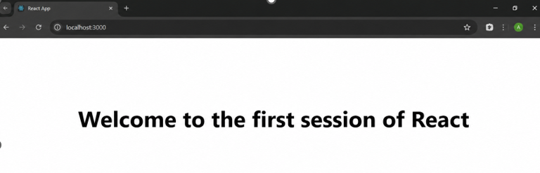
EXERCISE 2:
CODE:
src/Components/Home.js
import React, { Component } from "react";
class Home extends Component {
render() {
return (
<h2>Welcome to the Home page of Student Management Portal</h2>
);
}
}
export default Home;
src/Components/About.js
import React, { Component } from "react";
class About extends Component {
render() {
return (
<h2>Welcome to the About page of the Student Management Portal</h2>
);
}
}
export default About;
src/Components/Contact.js
import React, { Component } from "react";
class Contact extends Component {
render() {
return (
<h2>Welcome to the Contact page of the Student Management Portal</h2>
);
}
}
export default Contact;
src/App.js
import React from "react";
import Home from "./Components/Home";
import About from "./Components/About";
import Contact from "./Components/Contact";
function App() {
return (
<div>
<Home />
<About />
<Contact />
</div>
);
}
export default App;
OUTPUT:
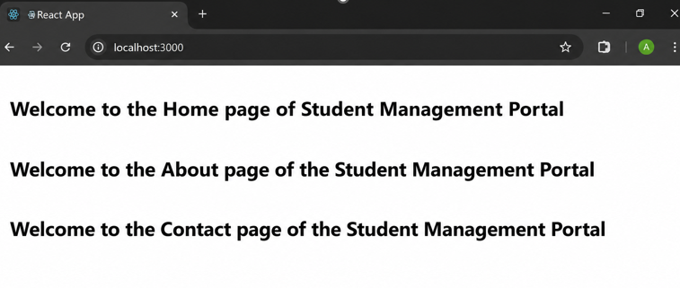
EXERCISE 3:
CODE:
src/Components/CalculateScore.js
import React from "react";
import "../Stylesheets/mystyle.css";
function CalculateScore(props) {
const average = props.total / props.goal;
return (
<div className="container">
<h1>Student Score Calculator</h1>

<p><b>Name:</b> {props.name}</p>
<p><b>School:</b> {props.school}</p>
<p><b>Total Marks:</b> {props.total}</p>
<p><b>Number of Subjects:</b> {props.goal}</p>
<p><b>Average Score:</b> {average}</p>
</div>
);
}
export default CalculateScore;

src/Stylesheets/mystyle.css
.container {
width: 400px;
margin: 40px auto;
padding: 20px;
border: 2px solid #333;
border-radius: 10px;
background-color: #f4f4f4;
text-align: left;
font-family: Arial, sans-serif;
}
h1 {
color: blue;
text-align: center;
}
p {
font-size: 18px;
margin: 10px 0;
}

src/App.js
import React from "react";
import CalculateScore from "./Components/CalculateScore";
function App() {
return (
<div>
<CalculateScore
name="John"
school="ABC Higher Secondary School"
total={450}
goal={5}
/>
</div>
);
}
export default App;

OUTPUT:
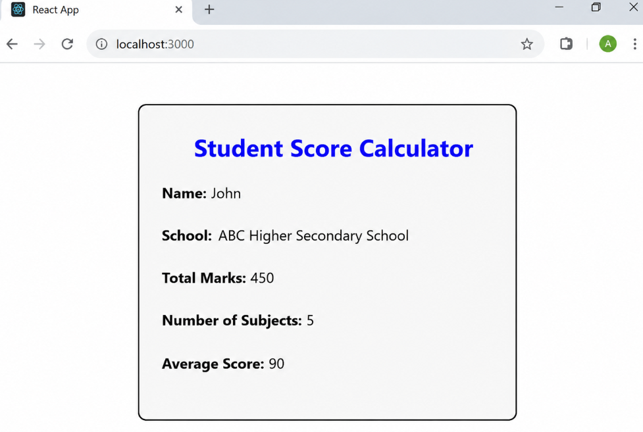
EXERCISE 4:
CODE:
src/Post.js
class Post {
constructor(userId, id, title, body) {
this.userId = userId;
this.id = id;
this.title = title;
this.body = body;
}
}
export default Post;

src/Posts.js
import React, { Component } from "react";
import Post from "./Post";
class Posts extends Component {
constructor(props) {
super(props);
this.state = {
posts: []
};
}
loadPosts = () => {
fetch("https://jsonplaceholder.typicode.com/posts")
.then((response) => response.json())
.then((data) => {
const posts = data.map(
(item) => new Post(item.userId, item.id, item.title, item.body)
);
this.setState({ posts });
})
.catch((error) => {
throw error;
});
};
componentDidMount() {
this.loadPosts();
}
componentDidCatch(error, info) {
alert("Error: " + error);
console.log(error, info);
}
render() {
return (
<div>
<h1>Blog Posts</h1>
{this.state.posts.map((post) => (
<div key={post.id}>
<h2>{post.title}</h2>
<p>{post.body}</p>
<hr />
</div>
))}
</div>
);
}
}

export default Posts;

src/App.js
import React from "react";
import Posts from "./Posts";
function App() {
return (
<div>
<Posts />
</div>
);
}
export default App;
OUTPUT:
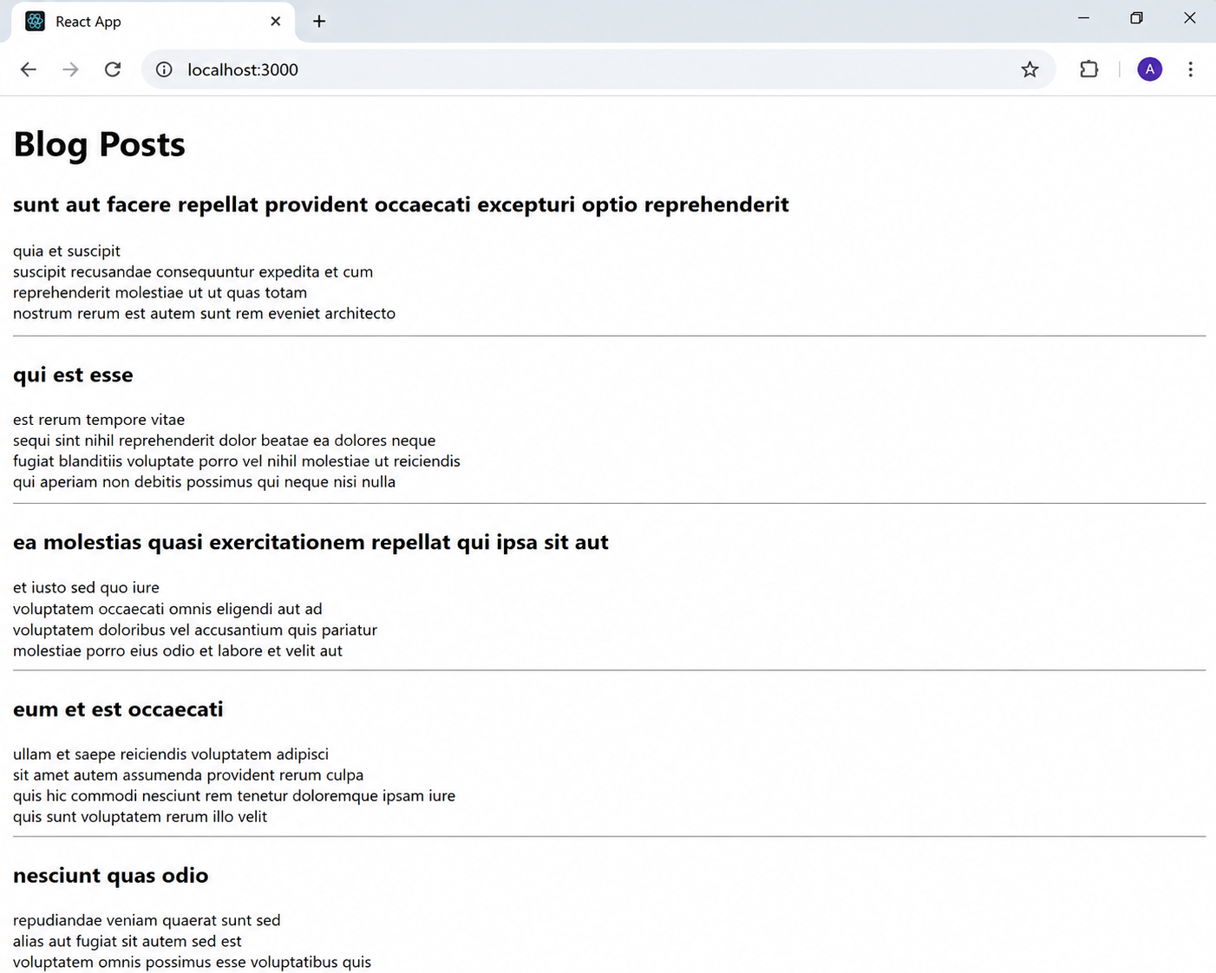
EXERCISE 5:
CODE:
src/CohortDetails.module.css
.box {
width: 300px;
display: inline-block;
margin: 10px;
padding: 10px 20px;
border: 1px solid black;
border-radius: 10px;
}
dt {
font-weight: 500;
}

src/CohortDetails.js
import React from "react";
import styles from "./CohortDetails.module.css";
function CohortDetails(props) {
return (
<div className={styles.box}>
<h3
style={{
color: props.status === "ongoing" ? "green" : "blue"
}}
>
{props.cohortName}
</h3>
<dl>
<dt>Started On</dt>
<dd>{props.startedOn}</dd>
<dt>Current Status</dt>
<dd>{props.status}</dd>
<dt>Coach</dt>
<dd>{props.coach}</dd>

<dt>Trainer</dt>
<dd>{props.trainer}</dd>
</dl>
</div>
);
}
export default CohortDetails;

src/App.js
import React from "react";
import CohortDetails from "./CohortDetails";
function App() {
return (
<div>
<CohortDetails
cohortName="INTADMDF10 - .NET FSD"
startedOn="22-Feb-2022"
status="ongoing"
coach="John"
trainer="David"
/>
<CohortDetails
cohortName="ADM21JF014 - Java FSD"
startedOn="10-Jan-2022"
status="completed"
coach="Peter"
trainer="James"
/>
</div>
);
}
export default App;
OUTPUT:
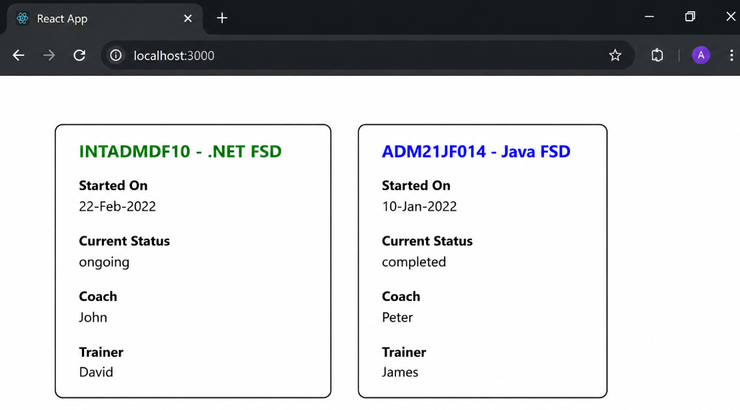
EXERCISE 9:
CODE:
src/ListofPlayers.js
import React from "react";
function ListofPlayers() {
const players = [
{ name: "Virat", score: 95 },
{ name: "Rohit", score: 82 },
{ name: "Gill", score: 65 },
{ name: "Rahul", score: 58 },
{ name: "Hardik", score: 77 },
{ name: "Jadeja", score: 69 },
{ name: "Surya", score: 88 },
{ name: "Pant", score: 73 },
{ name: "Bumrah", score: 45 },
{ name: "Shami", score: 60 },
{ name: "Siraj", score: 80 }
];
const lowScorePlayers = players.filter(player => player.score < 70);
return (
<div>
<h2>List of Players</h2>
<h3>All Players</h3>
<ul>
{players.map((player, index) => (
<li key={index}>
{player.name} - {player.score}
</li>
))}
</ul>
<h3>Players with Score Below 70</h3>
<ul>
{lowScorePlayers.map((player, index) => (
<li key={index}>
{player.name} - {player.score}
</li>
))}
</ul>
</div>
);
}
export default ListofPlayers;

src/IndianPlayers.js
import React from "react";
function IndianPlayers() {
const players = [
"Virat",
"Rohit",
"Gill",
"Rahul",
"Hardik",
"Jadeja"
];
const [odd1, even1, odd2, even2, odd3, even3] = players;
const T20Players = ["Virat", "Rohit", "Surya"];
const RanjiPlayers = ["Pujara", "Rahane", "Iyer"];
const mergedPlayers = [...T20Players, ...RanjiPlayers];
return (
<div>
<h2>Odd Team Players</h2>
<ul>
<li>{odd1}</li>
<li>{odd2}</li>
<li>{odd3}</li>
</ul>
<h2>Even Team Players</h2>
<ul>
<li>{even1}</li>
<li>{even2}</li>
<li>{even3}</li>
</ul>
<h2>Merged Players</h2>
<ul>
{mergedPlayers.map((player, index) => (
<li key={index}>{player}</li>
))}
</ul>
</div>
);
}
export default IndianPlayers;

src/App.js
import React from "react";
import ListofPlayers from "./ListofPlayers";
import IndianPlayers from "./IndianPlayers";
function App() {
const flag = true;
if (flag) {
return (
<div>
<ListofPlayers />
</div>
);
} else {
return (
<div>
<IndianPlayers />
</div>
);
}
}
export default App;
OUTPUT:
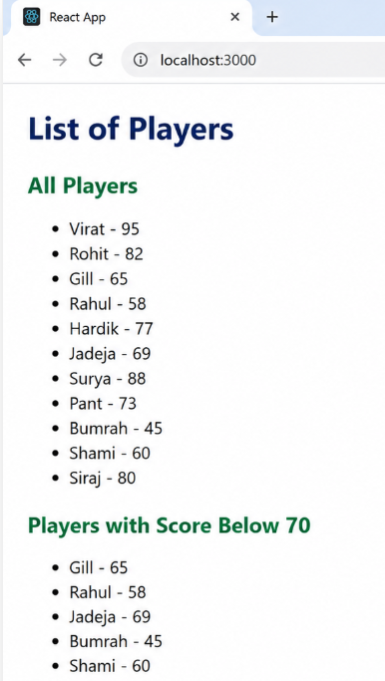

EXERCISE 10:
CODE:
src/App.js
import React from "react";
function App() {
const officeSpaces = [
{
name: "DBS",
rent: 50000,
address: "Chennai",
image:
"https://images.unsplash.com/photo-1497366754035-f200968a6e72?w=600"
},
{
name: "Regus",
rent: 75000,
address: "Bangalore",
image:
"https://images.unsplash.com/photo-1497366811353-6870744d04b2?w=600"
},
{
name: "WeWork",
rent: 90000,
address: "Hyderabad",
image:
"https://images.unsplash.com/photo-1497366412874-3415097a27e7?w=600"
}
];

return (
<div style={{ padding: "20px", fontFamily: "Arial" }}>
<h1>Office Space Rental App</h1>
{officeSpaces.map((office, index) => (
<div
key={index}
style={{
border: "1px solid gray",
borderRadius: "8px",
padding: "15px",
marginBottom: "20px",
width: "350px"
}}
>
<img
src={office.image}
alt={office.name}
width="300"
height="200"
/>
<h2>{office.name}</h2>
<p>
<b>Rent: </b>
<span
style={{
color: office.rent < 60000 ? "red" : "green"
}}
>
₹{office.rent}
</span>
</p>
<p>
<b>Address:</b> {office.address}
</p>
</div>
))}
</div>
);
}
export default App;

OUTPUT:
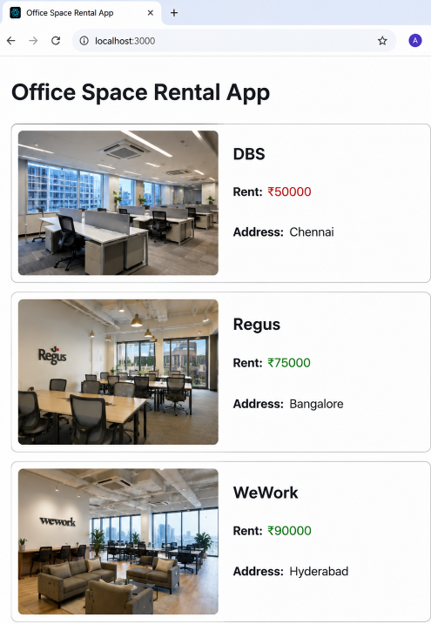
EXERCISE 11:
CODE:
src/CurrencyConvertor.js
import React, { Component } from "react";
class CurrencyConvertor extends Component {
constructor(props) {
super(props);

this.state = {
rupees: "",
euro: ""
};
}
handleChange = (event) => {
this.setState({ rupees: event.target.value });
};
handleSubmit = () => {
const euro = (this.state.rupees / 90).toFixed(2);
this.setState({ euro });
};
render() {
return (
<div>
<h2>Currency Convertor</h2>
<input
type="number"
placeholder="Enter Rupees"
value={this.state.rupees}
onChange={this.handleChange}
/>
<button onClick={this.handleSubmit}>Convert</button>
<h3>Euro: €{this.state.euro}</h3>
</div>
);
}
}

export default CurrencyConvertor;

src/App.js
import React, { Component } from "react";
import CurrencyConvertor from "./CurrencyConvertor";
class App extends Component {
constructor(props) {
super(props);
this.state = {
count: 0
};
}
increment = () => {
this.setState({ count: this.state.count + 1 });
};
decrement = () => {
this.setState({ count: this.state.count - 1 });
};
sayHello = () => {
alert("Hello! Have a nice day.");
};
handleIncrement = () => {
this.increment();
this.sayHello();
};
sayWelcome = (message) => {
alert(message);
};
onPress = () => {
alert("I was clicked");
};
render() {
return (
<div style={{ padding: "20px" }}>
<h1>Counter: {this.state.count}</h1>
<button onClick={this.handleIncrement}>Increment</button>
<button onClick={this.decrement}>Decrement</button>
<br />
<br />
<button onClick={() => this.sayWelcome("Welcome")}>
Say Welcome
</button>
<br />
<br />
<button onClick={this.onPress}>OnPress</button>
<hr />
<CurrencyConvertor />
</div>
);
}
}
export default App;

OUTPUT:
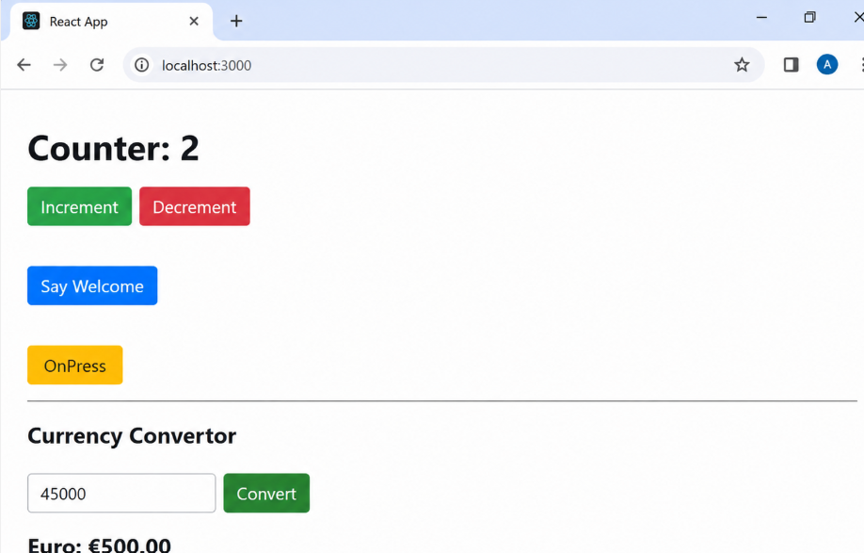
EXERCISE 12:
CODE:
src/GuestPage.js
import React from "react";
function GuestPage() {
return (
<div>
<h2>Welcome Guest</h2>
<h3>Flight Details</h3>
<table border="1" cellPadding="10">
<thead>
<tr>
<th>Flight</th>
<th>From</th>
<th>To</th>
<th>Fare</th>
</tr>
</thead>
<tbody>
<tr>
<td>AI101</td>
<td>Chennai</td>
<td>Delhi</td>
<td>₹5000</td>
</tr>
<tr>
<td>AI202</td>
<td>Bangalore</td>
<td>Mumbai</td>
<td>₹4500</td>
</tr>
</tbody>
</table>
<p>Please login to book your tickets.</p>
</div>
);
}
export default GuestPage;

src/UserPage.js
import React from "react";

function UserPage() {
return (
<div>
<h2>Welcome User</h2>
<h3>Book Your Flight Tickets</h3>

<table border="1" cellPadding="10">
<thead>
<tr>
<th>Flight</th>
<th>From</th>
<th>To</th>
<th>Fare</th>
</tr>
</thead>
<tbody>
<tr>
<td>AI101</td>
<td>Chennai</td>
<td>Delhi</td>
<td>₹5000</td>
</tr>
<tr>
<td>AI202</td>
<td>Bangalore</td>
<td>Mumbai</td>
<td>₹4500</td>
</tr>
</tbody>
</table>
<button>Book Ticket</button>
</div>
);
}
export default UserPage;

src/App.js
import React, { Component } from "react";
import GuestPage from "./GuestPage";
import UserPage from "./UserPage";
class App extends Component {
constructor(props) {
super(props);
this.state = {
isLoggedIn: false
};
}
login = () => {
this.setState({ isLoggedIn: true });
};
logout = () => {
this.setState({ isLoggedIn: false });
};
render() {
return (
<div style={{ padding: "20px" }}>
<h1>Ticket Booking App</h1>
{this.state.isLoggedIn ? (
<div>
<button onClick={this.logout}>Logout</button>
<UserPage />
</div>
) : (
<div>
<button onClick={this.login}>Login</button>
<GuestPage />
</div>
)}
</div>
);
}
}
export default App;

OUTPUT:
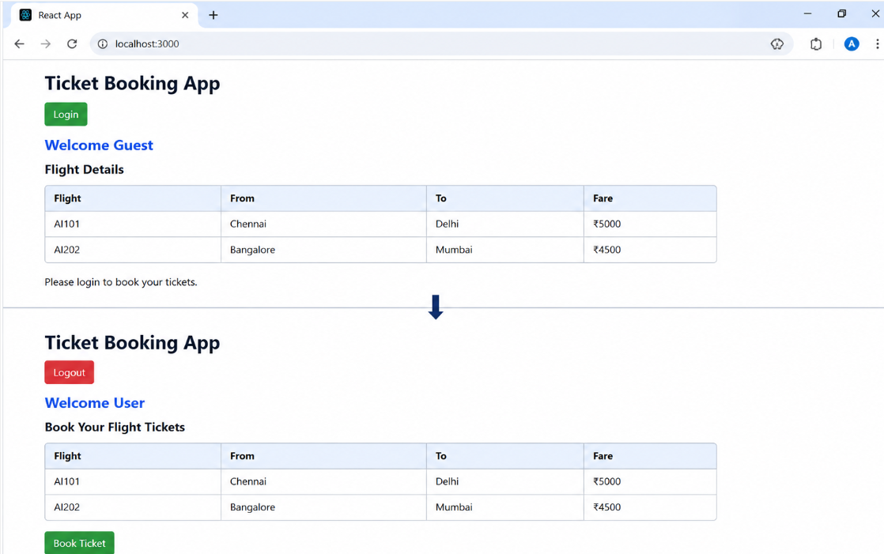
EXERCISE 13:
CODE:
src/BookDetails.js
import React from "react";
function BookDetails() {
const books = [
{ id: 1, name: "React Basics", author: "Jordan Walke", price: 450 },
{ id: 2, name: "Java Programming", author: "James Gosling", price: 650 },
{ id: 3, name: "Python Essentials", author: "Guido van Rossum", price: 550 }
];
return (
<div>
<h2>Book Details</h2>
<ul>
{books.map((book) => (
<li key={book.id}>
<b>{book.name}</b> | {book.author} | ₹{book.price}
</li>
))}
</ul>
</div>
);
}
export default BookDetails;

src/BlogDetails.js
import React from "react";
function BlogDetails() {
const blogs = [
{
id: 1,
title: "Introduction to React",
author: "John"
},
{
id: 2,
title: "Understanding JSX",
author: "David"
}
];
return (
<div>
<h2>Blog Details</h2>
<ul>
{blogs.map((blog) => (
<li key={blog.id}>
<b>{blog.title}</b> - {blog.author}
</li>
))}
</ul>
</div>
);
}
export default BlogDetails;

src/CourseDetails.js
import React from "react";
function CourseDetails() {
const courses = [
{
id: 1,
name: "React",
duration: "30 Days"
},
{
id: 2,
name: "Java Full Stack",
duration: "60 Days"
}
];

return (
<div>
<h2>Course Details</h2>
<ul>
{courses.map((course) => (
<li key={course.id}>
<b>{course.name}</b> - {course.duration}
</li>
))}
</ul>
</div>
);
}

export default CourseDetails;

src/App.js
import React from "react";
import BookDetails from "./BookDetails";
import BlogDetails from "./BlogDetails";
import CourseDetails from "./CourseDetails";
function App() {
const showBook = true;
const showBlog = false;
const showCourse = true;
return (
<div style={{ padding: "20px" }}>
<h1>Blogger App</h1>
{/* If-Else using Ternary */}
{showBook ? <BookDetails /> : <p>Book Details Hidden</p>}
<hr />
{/* Logical AND */}
{showBlog && <BlogDetails />}
<hr />
{/* Element Variable */}
{(() => {
let component;
if (showCourse) {
component = <CourseDetails />;
} else {
component = <p>Course Details Hidden</p>;
}
return component;
})()}
</div>
);
}
export default App;

OUTPUT:
